1. Bugs on the site <https://www.headhunterhairstyling.com/>

* 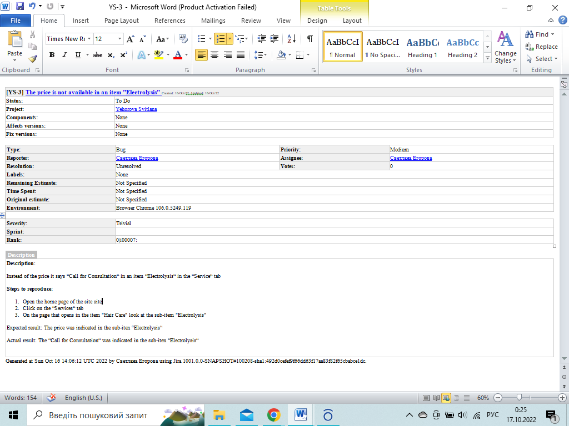

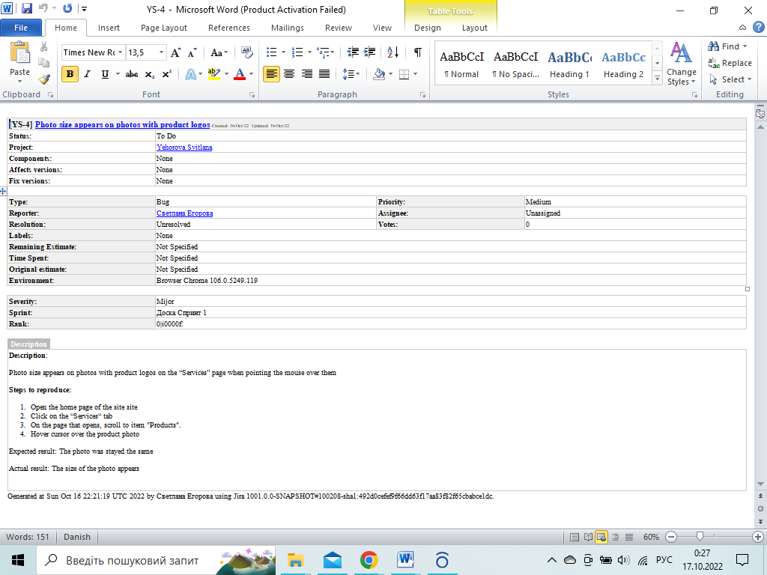

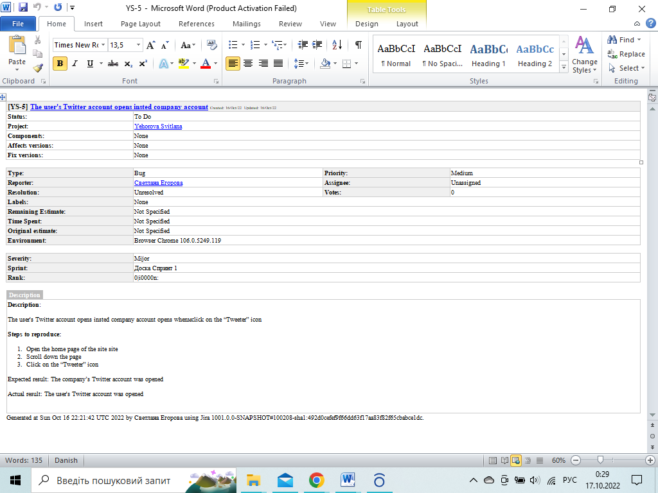

2. Severity - Minor / Priority - Highest

* The “Купить” button overlaps the scroll to increase the quantity of the product on the order page
* The company logo has a spelling mistake on the main page

Severity - Critical/Priority - Low

* Оne of the modules used by about every 300th user stopped working correctly аfter updating the program
* The application is crashing on passing very large input for processing (which is very rarely done).

3. Bug life cycle

New - a new bug has been detected and logged.

Assigned - a responsible developer has been assigned to fix the bug.

In progress - bug is in the process of fixing

Fixed - the bug is fixed and you can take it to work for re-checking

Verified - the tester checks that the bug was really fixed.

Closed - means that the bug was fixed and the task is closed.

Reopen - puts the tester, shows that the bug is still reproduced on the build, in which it should already be fixed.

Not confirmed - shows that the developer cannot reproduce this bug and provides comments for the tester, for a more detailed description

The “New” “Assigned” “In progress” “Fixed” “Verified” “Closed” items are the main life cycles of the bug. The “Reopen” “Not confirmed” items are should not be used when correctly fixing and describing the bug, but do not leave out the human factor